Created by: Dr. Zoltán Subecz, John von Neumann University, Kecskemét, GAMF Faculty of Engineering and Computer Science, Informatics Department, subecz.zoltan@gamf.uni-neumann.hu

GitHub description
Content
Github vs Gitlab – For what we need is both good - GitHub is older, so it is used by more people => I introduce GitHub here 2
GitHub basic 2
Git and GitHub 2
Registration 2
Two main possibility: CLI: Command line interface / Desktop: graphical interface: easier to use => I introduce the Desktop 2
Other possibility of use: larger IDE applications also provide GitHub access. e.g. IntelliJ, VSCode, PHPStorm… 2
Github Desktop installation, settings 2
1st exercise 3
Create a New Repository on your hard drive… 3
Create the test1.txt and test2.txt files with some content. 4
Commit 4
Modify the files => Commit. 5
Delete one of the files => Commit. 5
Change repository visibility to public 5
Creating a branch 5
Create a branch 6
Making and committing changes 6
Opening a pull request 7
Merging your pull request 8
Delete the readme-edits branch 8
Create a new branch with branch2 name 8
Modify the branches 8
2nd exercise - Contributing to projects 10
Register with another email address too, with another browser. It is best to create it on another machine 10
About forking 10
Forking a repository 10
Cloning a fork 10
Making and pushing changes 11
Making a pull request 11
View contributors 12

Github vs Gitlab – For what we need is both good - GitHub is older, so it is used by more people => I introduce GitHub here

https://www.geeksforgeeks.org/difference-between-gitlab-and-github/
https://about.gitlab.com/devops-tools/github-vs-gitlab/
https://usersnap.com/blog/gitlab-github/
https://www.upgrad.com/blog/github-vs-gitlab-difference-between-github-and-gitlab/
https://spectralops.io/blog/github-vs-gitlab/
https://kinsta.com/blog/gitlab-vs-github/
https://www.coscreen.co/blog/gitlab-vs-github/
https://rigorousthemes.com/blog/gitlab-vs-github-which-is-better/

GitHub basic

https://docs.github.com/en
https://docs.github.com/en/get-started/quickstart/hello-world

Git and GitHub
https://product.hubspot.com/blog/git-and-github-tutorial-for-beginners
A quick aside: git and GitHub are not the same thing. Git is an open-source, version control tool created in 2005 by developers working on the Linux operating system; GitHub is a company founded in 2008 that makes tools which integrate with git. You do not need GitHub to use git, but you cannot use GitHub without using git. There are many other alternatives to GitHub, such as GitLab, BitBucket, and “host-your-own” solutions such as gogs and gittea. All of these are referred to in git-speak as “remotes”, and all are completely optional. You do not need to use a remote to use git, but it will make sharing your code with others easier.

Registration
https://github.com/

Sign up

Two main possibility: CLI: Command line interface / Desktop: graphical interface: easier to use => I introduce the Desktop

https://docs.github.com/en/get-started/quickstart/set-up-git

Other possibility of use: larger IDE applications also provide GitHub access. e.g. IntelliJ, VSCode, PHPStorm…

https://www.jetbrains.com/help/idea/github.html
https://code.visualstudio.com/docs/editor/github
https://www.jetbrains.com/help/phpstorm/github.html

Github Desktop installation, settings

https://docs.github.com/en/desktop/installing-and-configuring-github-desktop

Download
https://desktop.github.com/

Install it
Start the installed GitHub Desktop
Sign in

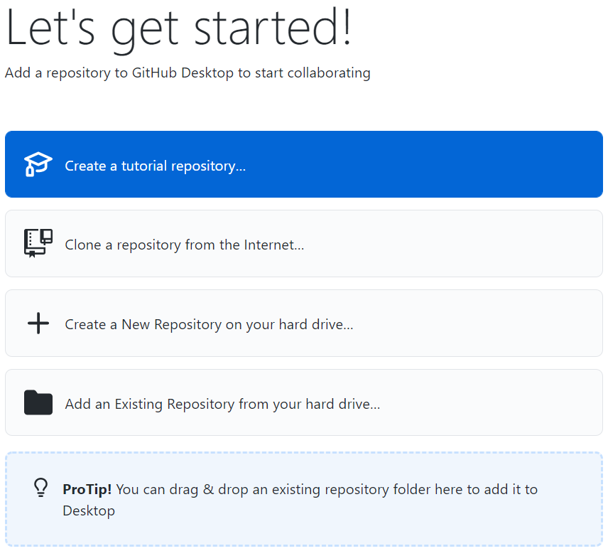

1st exercise

Based on: https://docs.github.com/en/get-started/quickstart/hello-world

Create a New Repository on your hard drive…

Create a folder for the Repository, e.g. C:\GitExercise

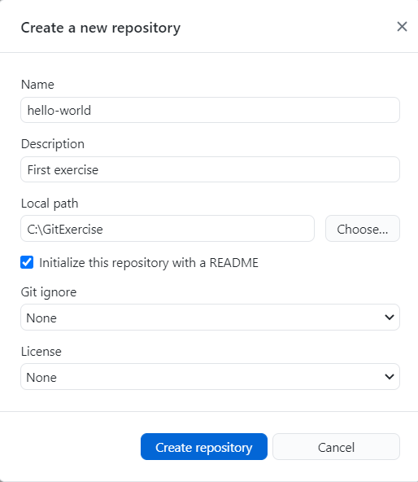

=> Create repository
=> Publish repository

Look at the content of the C:\GitExercise folder.

Some options are offered:
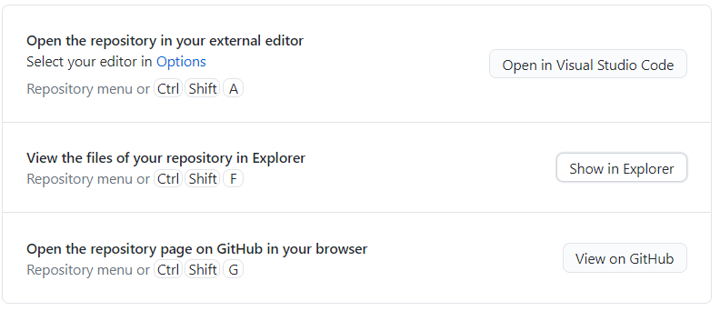

Try it:
Open in Visual Studio Code
View on GitHub => It opens the https://github.com/******/hello-world page.

Creating and modifying files

Create the test1.txt and test2.txt files with some content.

Commit
In Desktop: commit:
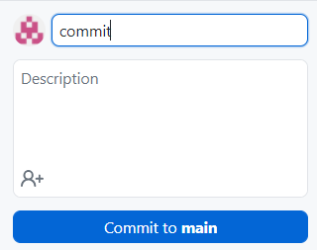

Then Push origin:
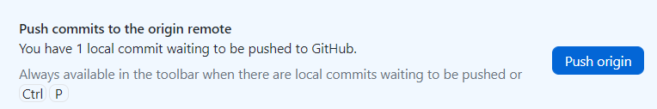

Then: View on GitHub:

Modify the files => Commit.

Delete one of the files => Commit.

Change repository visibility to public

On https://github.com/****/hello-world page: Settings: 
=> Danger Zone
Change repository visibility (This repository is currently private.)
Change visibility => Make public

Creating a branch

Branching lets you have different versions of a repository at one time.
By default, your repository has one branch named main that is considered to be the definitive branch. You can use branches to experiment and make edits before committing them to main.
When you create a branch off the main branch, you're making a copy, or snapshot, of main as it was at that point in time. If someone else made changes to the main branch while you were working on your branch, you could pull in those updates.

This diagram shows:

The main branch
A new branch called feature
The journey that feature takes before it's merged into main

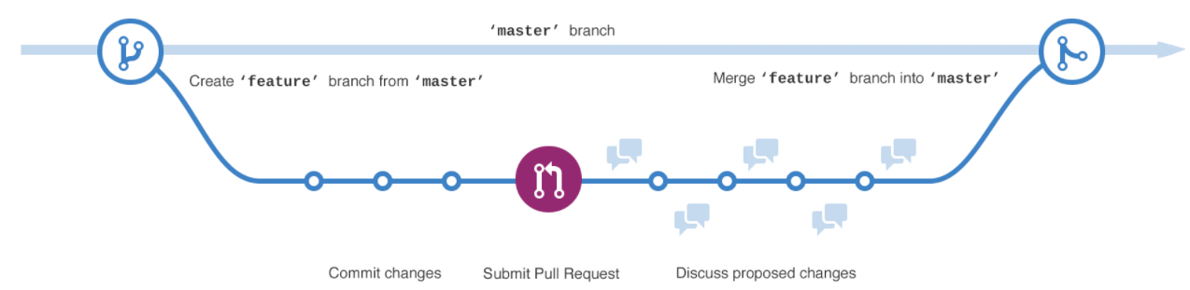

Have you ever saved different versions of a file? Something like:
- story.txt
- story-joe-edit.txt
- story-joe-edit-reviewed.txt
Branches accomplish similar goals in GitHub repositories.

Create a branch

Click the Code tab of your hello-world repository.
Click the drop down at the top of the file list that says main.
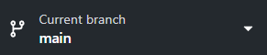
Type a branch name, readme-edits, into the text box.
Click Create branch: readme-edits from main.

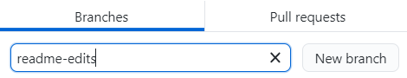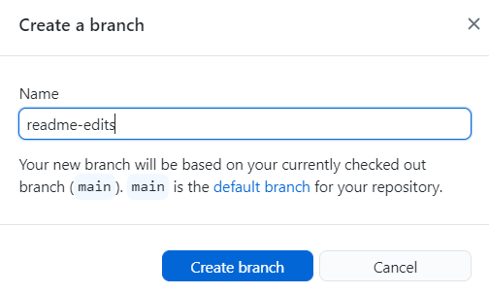

Now you have two branches, main and readme-edits. Right now, they look exactly the same. Next you'll add changes to the new branch.

Making and committing changes

When you created a new branch in the previous step, GitHub brought you to the code page for your new readme-edits branch, which is a copy of main.

You can make and save changes to the files in your repository. On GitHub, saved changes are called commits. Each commit has an associated commit message, which is a description explaining why a particular change was made. Commit messages capture the history of your changes so that other contributors can understand what you’ve done and why.

- Click the README.md file.

- Click to edit the file.
We can edit the file with NotePad as well.
- In the editor, write a bit about yourself.
- In the Commit changes box, write a commit message that describes your changes.
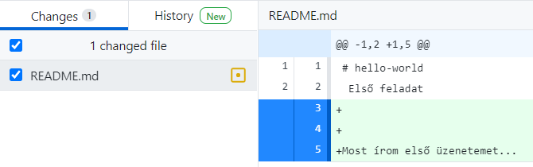 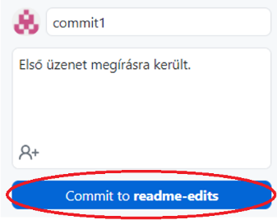

Look at the content of the README.md file on https://github.com/****/hello-world page before and after the Commit.

- Click Commit changes.
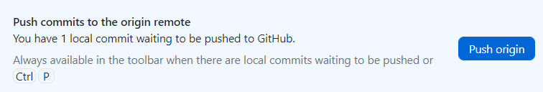

These changes will be made only to the README file on your readme-edits branch, so now this branch contains content that's different from main.

Opening a pull request

Now that you have changes in a branch off of main, you can open a pull request.

Pull requests are the heart of collaboration on GitHub. When you open a pull request, you're proposing your changes and requesting that someone review and pull in your contribution and merge them into their branch. Pull requests show diffs, or differences, of the content from both branches. The changes, additions, and subtractions are shown in different colors.

As soon as you make a commit, you can open a pull request and start a discussion, even before the code is finished.

By using GitHub's @mention feature in your pull request message, you can ask for feedback from specific people or teams, whether they're down the hall or 10 time zones away.

You can even open pull requests in your own repository and merge them yourself. It's a great way to learn the GitHub flow before working on larger projects.

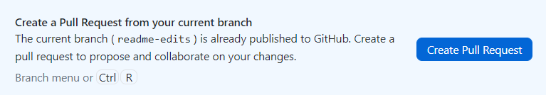

- Click the Pull requests tab of your hello-world repository.
- Click New pull request
- In the Example Comparisons box, select the branch you made, readme-edits, to compare with main (the original).
- Look over your changes in the diffs on the Compare page, make sure they're what you want to submit.
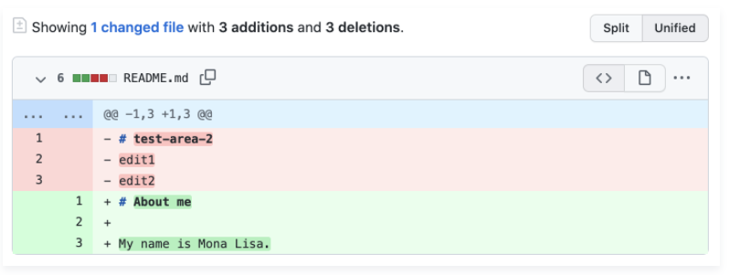
- Click Create pull request.
- Give your pull request a title and write a brief description of your changes. You can include emojis and drag and drop images and gifs.
- Click Create pull request.

Merging your pull request

In this final step, you will merge your readme-edits branch into the main branch.

- Click Merge pull request to merge the changes into main.
- Click Confirm merge.
Look at the main branch after merge:
Egyesítés után nézzük meg a main branch-t: the changes appeared there as well

Delete the readme-edits branch

- Go ahead and delete the branch, since its changes have been incorporated, by clicking Delete branch.

Create a new branch with branch2 name

Modify the branches

- Select branch2
- Create a file with some content + Commit
- Look at the content of the folder: you can find the file there
- Look at the remote server: the file is not there
- 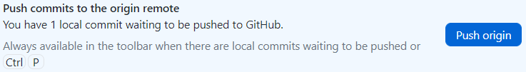
- Look at the remote server: you can find the file there
- Look at the remote server at main branch: the file is not there
- Go to main branch
- Look at the content of the folder: you can’t find the file there
- Go back to branch2
- Create pull request
- Merge pull request
- Look at the remote server at main branch: you can find the file there
- Go to main branch
- Look at the content of the folder: you can’t find the file there
- 
- Look at the content of the folder: you can’t find the file there
- Look at the content of the folder: you can find the file there

2nd exercise - Contributing to projects
Learn how to contribute to a project through forking.

Register with another email address too, with another browser. It is best to create it on another machine
It is better to create it on another machine because some settings remain in the Desktop from the previous state.
https://github.com/desktop/desktop/issues/3707

https://docs.github.com/en/get-started/quickstart/contributing-to-projects

About forking
Creating a "fork" is producing a personal copy of someone else's project. Forks act as a sort of bridge between the original repository and your personal copy. You can submit pull requests to help make other people's projects better by offering your changes up to the original project. Forking is at the core of social coding at GitHub.

Forking a repository

- Go to the previously created page: https://github.com/****/hello-world
- Click Fork:
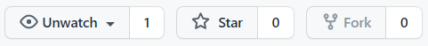
- The GitHub creates a copy of the hello-world repository
- The fork page is created: https://github.com/*****NEW/hello-world

Cloning a fork
The hello-worlds repository has been copied (fork), but it is present only on GitHub. To work with it you need to clone it to your local machine.

If we use the same machine with the other user
Log out and log in to GitHub Desktop with the new registration data.
File / Options / Sign out then Sign in
If you can’t see the login page in your browser, first log in by entering the Git URL you opened in the browser.
Set up new user data in Desktop
If you do not set this, you can still send the new file, but on https://github.com/****/hello-world page we can see that the file was created by the same person.
At File/ Options / Git / Name and Email – be the data of the new user.

If we use the same machine with the other user, we will also see the previous user's repositories in the Desktop. Therefore, it is better to use another computer with the other user. But we can still solve the problem: we do not create the repository here as hello-world, but as hello-world2.

- Go to page: https://github.com/*****NEW/hello-world
- 
-  Perform the cloning with Desktop
- Allow
Enter a folder name that is not already on the computer
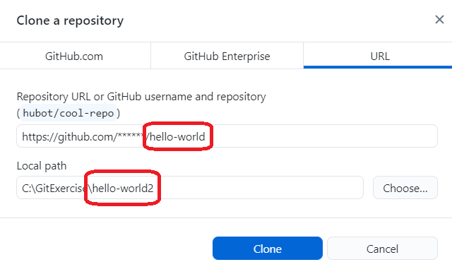

- Clone => Look at the created folder
- 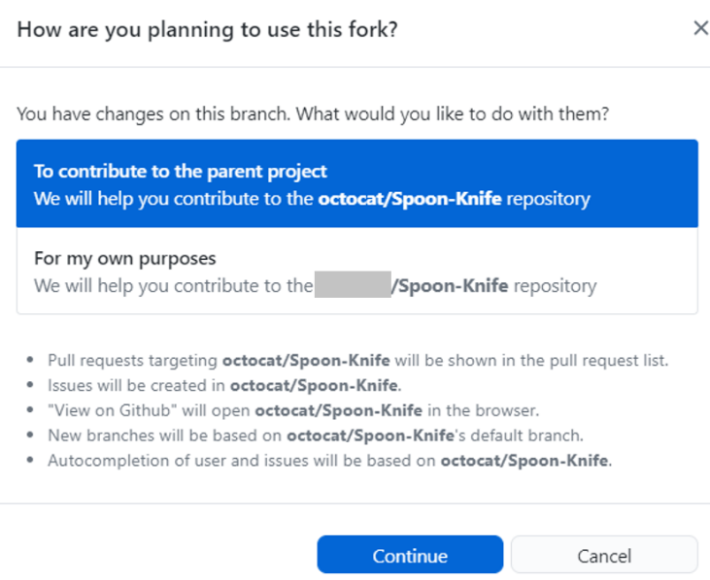

The following is the same process we learned in the previous chapter:

Making and pushing changes

- Create a test10.txt file with some content
- Commit
- 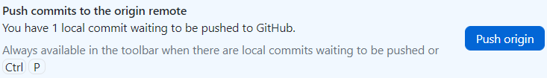
- Look at the fork page: https://github.com/****NEW/hello-world
The file can be seen there as well

Making a pull request
At last, you're ready to propose changes into the main project! This is the final step in producing a fork of someone else's project, and arguably the most important. If you've made a change that you feel would benefit the community as a whole, you should definitely consider contributing back.

- On https://github.com/****NEW/hello-world page:
- Contribute:
- 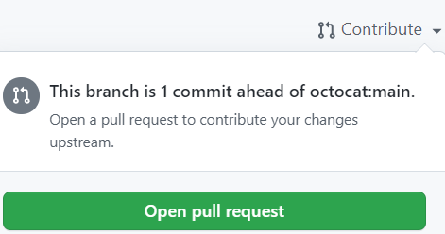
- Create pull request

The owner must allow the merging:

Go to the original page: https://github.com/****/hello-world
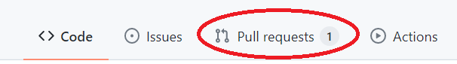

Click on the pull request name:
=> Create test10.txt



On https://github.com/******/hello-world page shows that the test10.txt file has appeared.

To display the file in the local c:\GitExercise\hello-world\ folder:

Login on Desktop with the first user



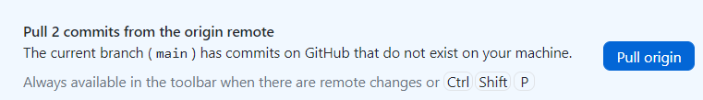

View contributors

You can view it in several places on https://github.com/******/hello-world page
- Main page bottom right corner
- by clicking on a file name or folder name
- 
-  / Contributions, Networks

